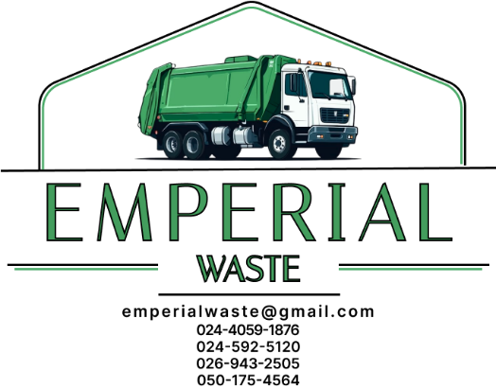

TOILET PULL PRICING CATALOG

Truck | Capacity | Price
Double Axle | 6000 gal | GHC 2000
One and Half Axle | 3000 gal | GHC 1800
Single Axle | 2000 gal | GHC 1600

10/10/2024

